**Manual for global online GC-YIBs**

1. **Contents**

YIBs source code: /Code.12.0.0/YIBs

1. main function：yibs_loop.F

Run parameters: input.geos

1. **How to run**

The compile and run processes of GC-YIBs are similar to those of GEOS-Chem.

(a) Copy input.geos to your run directory and replace original input.geos.

1. Go to your run directory, compile GC-YIBs model as follows:

make superclean

make -j4 mpbuild

(c) After compilation, run executive ‘geos.mp’.

1. **How to revise run parameters**

The YIBs menu (red box) has been added in input.geos

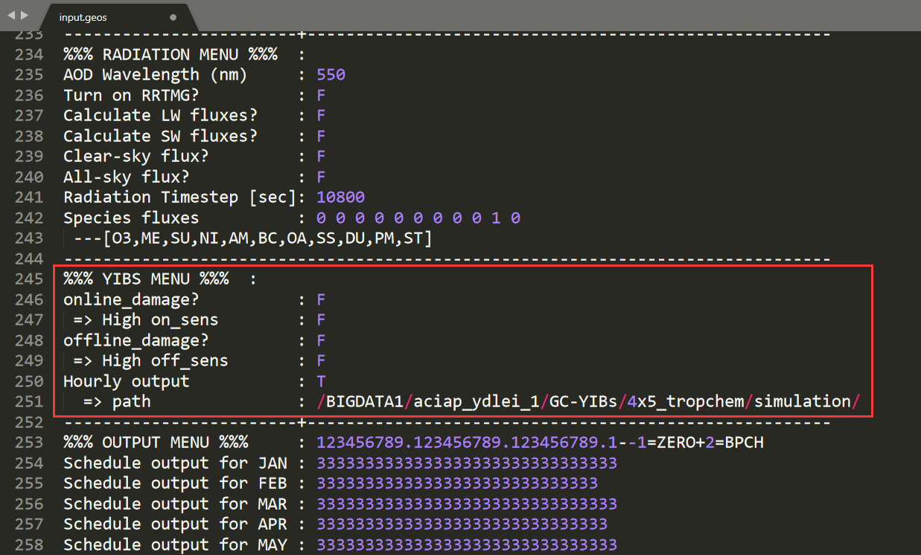

Adjust running parameters:

online_damage=T

Consider online ozone vegetation damage

High on_sens=T

Represent online high ozone damage sensitivity

High on_sens=F

Represent online low ozone damage sensitivity

offline_damage=T

Consider offline ozone vegetation damage

High off_sens=T

Represent offline high ozone damage sensitivity

High off_sens=F

Represent offline low ozone damage sensitivity

Hourly output=T

Output hourly surface [O3] and O3 dry deposition velocity

path=/……/

Hourly output files path